PROJECT DESIGN PHASE
Problem – Solution Fit Template

Date | 1 November 2025
Team ID | NM2025TMID05413
Project Name | Educational Organisation Using ServiceNow
Maximum Marks | 2 Marks

Problem – Solution Fit Template
The Problem–Solution Fit simply means identifying a real issue faced by
educational institutions and creating a solution that truly resolves it. In this project, the focus is on automating and simplifying the complex administrative and
academic tasks within an educational organization using the ServiceNow platform.

Purpose:
- To automate manual administrative processes such as admissions, student record management, and faculty data handling through ServiceNow.
- To streamline communication between departments and improve coordination within the educational organization.
- To reduce human errors and delays by introducing digital workflows and real- time data access.
- To enhance data transparency and monitoring of student progress through automated forms and dashboards.
- To build a scalable and efficient ServiceNow-based management system that can be customized for any educational institution.

Template:
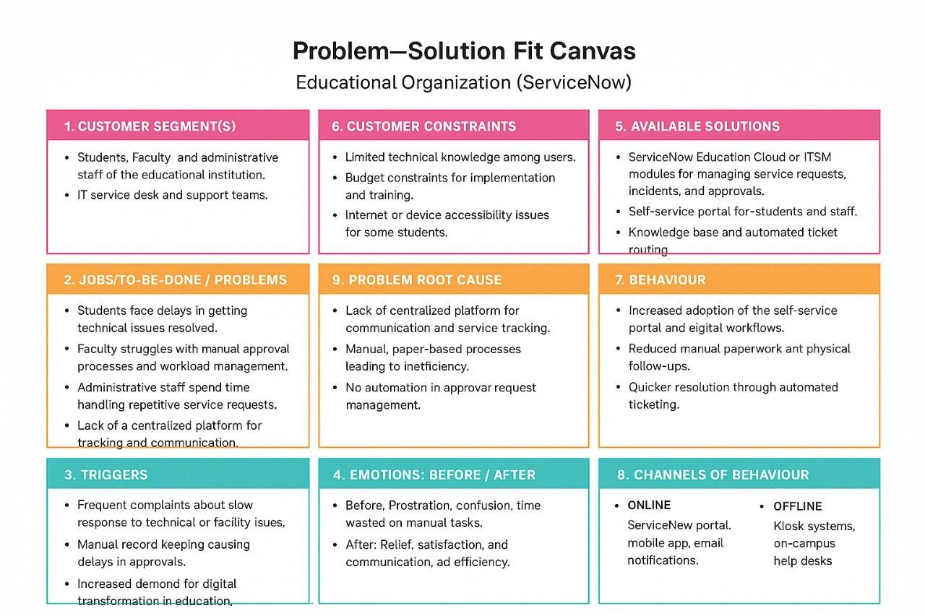

The project “Educational Organisation Using ServiceNow” addresses the growing need for automation and efficiency in managing educational institutions. Many organizations still depend on manual processes for maintaining student and faculty data, handling admissions, and monitoring performance, which leads to
data duplication, inefficiency, and delays.
This project provides a ServiceNow-based Educational Management System designed to centralize all administrative and academic operations. The system simplifies workflows such as creating tables, form layouts, form designs, number maintenance, and process flows, ensuring all institutional activities are performed accurately and efficiently.
The solution helps improve data integrity, efficiency, and user satisfaction by reducing manual work, enabling real-time access to data, and fostering smooth coordination between departments.
By implementing this ServiceNow solution, educational institutions can transition into a smart, digital ecosystem that enhances productivity, strengthens data management, and supports effective decision-making across all levels of
management.

